Directions: How to Setup a Cable Modem + Router + Switch

Note: This includes directions on cloning a Linux Mint PC’s MAC address onto a LibreCMC router’s WAN to get around restrictions on the # of public IP addresses an ISP will typically assign

Below is a diagram of how you should setup your penguin router and connect it to a cable modem. If your cable modem is an actual cable modem (no wifi, a single ehternet port, basically no routing/NAT built in, etc) these are the directions you want to follow.

When you initially setup the cable modem you will almost certainly have connected it to a computer directly via an ethernet cable from the PC to the LAN port on the cable modem. You would then have checked to see if everything is working (opened a web browser and tried accessing one site or another). Make sure you’ve gotten at least that far before continueing further with these directions.

If you have any problems with getting the cable modem working the manufacturer of the cable modem should have directions in the box and a phone # to call if you have problems with getting it work with your particular cable provider. Generally speaking ISPs don’t like to support third party cable modems so it won’t do any good calling the cable company for assistance. That isn’t necessarily an issue. Usually you’ll be able to call the cable modem manufacturer for support. The cable modem manufactuer will be familiar with setting up the cable modem on the major cable providers networks. Once you’ve confirmed that this much is working you can follow the directions below to setup everything else.

So normally a cable ISP will issue a user a single public IPv4 address. This will usually be ‘locked’ to the first device (typically your computer). If everything is working then you should be able to access the internet on the computer (ie you’ve already done this now when you initially setup the cable modem).

If you connect another computer or the gigabit router now to the cable modem in place of the PC the ISP will not assign you a 2nd public IPv4 address since most ISPs will only issue you one public IPv4 address. This is fine. What it means is we have to get around a minor technical issue by cloning the MAC address of your computer onto the WAN port of the gigabit router.

Now is a good time to connect your modem, router(s), and switch as shown in the diagram below:
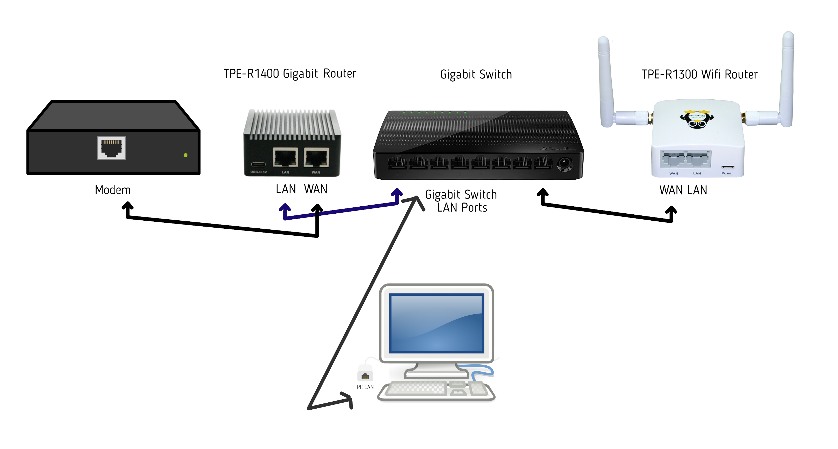
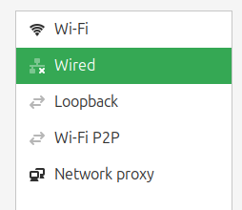
Assuming you are using Linux Mint on the PC go to the network icon in the lower right corner (you might need to look somewhere else if using another distribution or operating system, contact ThinkPenguin, Inc support for further assistance in identifying your computer’s MAC address). Left click on the network applet and select Network Settings. In the window that pops up you’ll see a list of devices on the left. One of them says Wired. Click on Wired.


You’ll then want to click on the gear icon on the right. You should see something that says Hardware Address: followed by a string like so: D2:34:90:34:B3:DD. This is your computer’s MAC address. Write down this MAC address as we need to enter it into the configuration of the router.

Open a web browser and enter https://192.168.10.1 into the address bar and then hit enter. You may get a warning about a self signed security certificate. This is actually fine and not a danger in this set of circumstances. If you get this message you will need to click a button that says Advanced... (this is true for at least Firefox, but other browsers may be a little different). A 2nd button will appear that says Accept the Risk and Continue. Click the button to continue.

This should open up a page that says LibreCMC login. Root is the default username and you will want to click the Log in button next. There is no password set by default so you can’t just log in. Note: It is a good idea to set a password, just make sure to write it down so you don’t forget it. Next go to the menu at the top, then Network, and Interfaces. You’ll see a tab that says Devices. Click it. Click the button that says Configure that is next to eth1. You will now need to click on the box that says MAC address. Enter the MAC address that you wrote down prior. Then click the save button. Then click the Save & Apply button. Then go to the menu at the top, go to System > Reboot. Then click the Perform reboot button.

Give the router a minute or two to reboot. Once it is rebooted you should be able to access the internet. If you open a web browser you can verify you have internet connectivity by visiting a website. For example enter https://www.thinkpenguin.com into the address bar and hit enter. You should see our website appear if everything worked.

If you run into any problems or have any further questions feel free to give us a call at 1-888-398-4465 or email us at support@thinkpenguin.com

